ble of Contents
Introduction 3
Solutions 3
Criteria 4
Evaluation 4
Mental Health Services 4
Cost 5
Benefits to Employees 6
Benefits to Employers 6
Physical Health Services 7
Cost 7
Benefits to Employees 8
Benefits to Employers 9
Flex-Scheduling 9
Cost 10
Benefits to Employees 10
Benefits to Employers 11
Recommendation 11
Implementation 12
Summary 13
Appendix 14
References 15

Introduction
The average full-time employee in America works 47 hours a week (Abadi, 2018). It is the norm in our country that many workers spend more time within their place of work than at home with their families. This is a problem that impacts the work-life balance of workers, and their overall mental and physical health – all being detrimental to morale. Employee morale is reflected by the attitude and satisfaction of employees within a workplace. Morale drives productivity. Morale is, “the state of the spirits of a person or group as shown by confidence, cheerfulness, discipline, and the performance of assigned tasks” (Pillay, 2010). Low employee morale is a problem that affects productivity, absenteeism and turnover, costing organizations money and even customers. By offering options for employees to increase their own happiness and overall satisfaction within the workplace, organizations can mitigate the damages of unsatisfied workers.
This report will discuss the problem of low employee morale, and assess three solutions for boosting employee morale, and keeping workers physically and mentally healthy.
Solutions
The three solutions for increasing employee morale are offering mental health services, physical health services, and flex-scheduling options. Mental health services have to do with employers offering Employee Assistance Programs (EAPs) to their workers, as well as normalizing the discussion of mental health within the workplace. Physical health services are a solution to low employee morale, by offering wellness programs and introducing an energized, active work culture to combat stress, fatigue, and chronic health challenges. By offering flexible scheduling options to employees, an organization can provide a better work-life balance and increase the happiness of its workers. These three solutions have been selected as the best alternatives to solve the problem of low morale, because they are all low-cost options that can assist employers in boosting productivity, job satisfaction, and retention.
Criteria
Each of the three solutions will be evaluated based on the following criteria: cost, benefits to employees, and benefits to employers. Cost is defined as how much employers expect to pay to implement each solution, as well as how much they expect to save, in the long-run, by implementing each solution. The benefits to employees will be analyzed by how each solution positively impacts employees. It is most important to evaluate the employee benefits, because morale revolves around the state of employee satisfaction. It is also important to analyze how employers will benefit, because they foot the cost and consequence of implementing such solutions. The benefits to employers are evaluated based on how each solution positively impacts the employing organization. Each of the criteria of evaluation will allow employers to assess whether each solution is the right resource to increase employee morale at its organization.
Evaluation
Mental Health Services
Low morale can be a side effect of poor mental health. Low morale leads to low levels of engagement, a loss of productivity, and increased costs of retaining, recruiting and training employees (Schaeffer, 2010). A loss of productivity in the workplace can be directly caused by the mental health of an organization's employees. Stress, depression, anxiety, and fatigue are leading drivers of work productivity impairment (Isaac, 2010). In 2020 alone, the world has dealt with a COVID-19 pandemic that has increased stress and anxiety levels in many. American workers are not only battling the pandemic, but also a stressful political climate, an unpredictable economic climate, while also maintaining their jobs and families. As a matter of fact, 91% of employees claim to experience moderate to extreme stress while working during the pandemic (Place, 2020). This staggering statistic shows that almost all employees have been battling their mental health during this crisis. By providing employees a space to discuss and normalize mental health struggles, they can begin to feel they are not alone and can begin solving the mental health struggles with which they have been dealing.
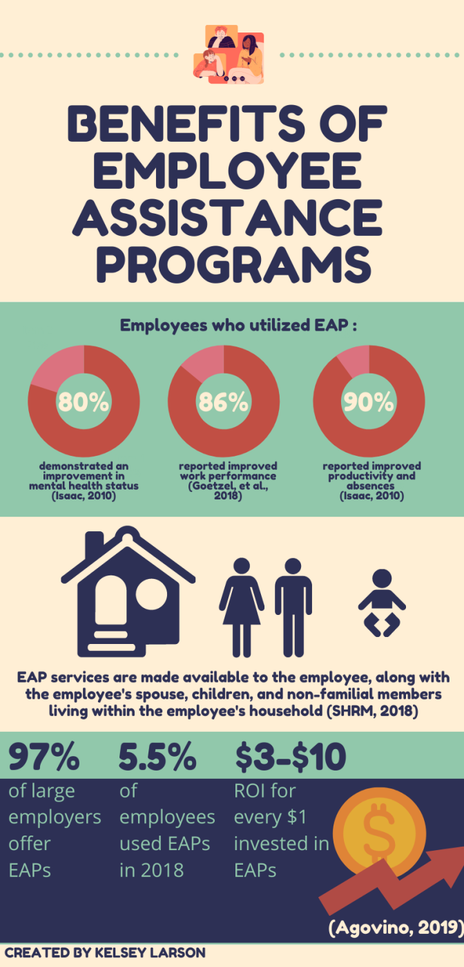
Cost
By normalizing mental health, or by offering mental health services to employees, employers can lift a burden from their workers' shoulders, and in turn, boost productivity and save money for the organization. Untreated mental illness costs the U.S. up to $193 billion in lost productivity annually (Kuretich, 2020). These funds could be dramatically lowered by employers deciding to invest in Employee Assistance Programs (EAPs) for their workers. EAPs are intervention programs, paid by employers, to help employees resolve a variety of personal problems that affect their work performance – whether it be substance abuse, mental, financial or family troubles, traumatic events, or legal challenges (SHRM, 2018). EAPs are a low-cost alternative for offering mental health services to employees. The average annual cost of an EAP, per employee, ranges from $12-$40 (Dunning, 2014). The investment in EAPs for employees can mitigate the damages and cost of poor mental health, and lower the risk of lost productivity.
Benefits to Employees
Employees benefit immensely from utilizing mental health services offered by employers. Johnson & Johnson decided to offer EAPs to workers at their company and found significant benefits of the decision. 80% of employees who utilized EAPs at Johnson & Johnson demonstrated an improvement in mental health status (Isaac, 2010). In further research conducted by the Journal of Occupational and Environmental Medicine (2018), 86% of EAP users reported improved work performance; 80% of EAP users reported high levels of work efficacy and satisfaction. Based on the evidence provided, EAPs are shown to improve the performance, productivity, satisfaction, and overall mental health status of users.
Benefits to Employers
Employers are also shown to significantly benefit from offering mental health services to their workers. By offering EAPs to employees at Johnson & Johnson, 90% of users reported improvement in productivity and reduced absenteeism (Isaac, 2010). A reduction in work absences and an increase in productivity allow an organization to reduce costs and save profits. In fact, Johnson & Johnson found a cost avoidance of $4,300 per EAP user (Isaac, 2010). The overall reward of implementing mental health programs is shown to exceed the investment of such programs. Based on the data above, by implementing EAPs for workers, employers can improve organizational productivity, work performance and efficacy, mental health status, the well-being of employees, job satisfaction and absenteeism, thus leading to improved workplace morale.
Physical Health Services
Wellness positively impacts the physical and mental health and wellbeing of those who are maintaining an active and healthy lifestyle. Poor physical health can lead to low morale. When employees are not focused on their physical well-being, absenteeism can be increased, as well as healthcare costs. By promoting health and wellness in the workplace, significant benefits are achieved. These benefits include: increased productivity, fewer injuries, reduced costs related to healthcare, productivity and absenteeism, as well as overall improved morale (Pope, 2019). Employers can promote health and wellness by offering amenities and building features to encourage physical activity, such as in-office gyms and standing desks. Lifestyle management programs can also be used to encourage physical activity, by offering incentives to reward healthy lifestyles. The CDC states:
Creating a culture of health, where health promotion is a valued part of the normal work day environment, will address employers’ health concerns for their employees and enhance their competitiveness by engaging employees, and presenting the company as an attractive place to work, (Centers for Disease Control and Prevention, 2015).
Emphasizing a physically healthy lifestyle is shown to impact the morale of employees within the workplace.
Cost
Overweight and obese workers, and those who have chronic health conditions, miss about 450 million additional days of work annually, costing about $153 billion in lost productivity (Witters & Agrawal, 2011). These costs can be mitigated by implementing physical health services to workers within an organization. The cost of offering physical health services to employees varies. Due to building and product costs, implementing building amenities and features would be more expensive than promoting in-office health programs. Johnson & Johnson reported the following cost benefits from implementing a health and wellness program: they found cumulative healthcare savings of approximately $250 million, and reduced health costs by $400 per employee each year (Isaac, 2010). As you can see, the cost-savings benefits outweigh the cost of implementing these programs.
Benefits to Employees
Physical health goes hand-in-hand with mental health. People who are physically healthy are shown to have improvements in their mental health, as well. “When employees feel energized by their workday experience, their productivity and on-the-job satisfaction both improve,” per Ferendeci, when speaking about building attributes that emphasize and encourage physical activity within a workplace (Energize employees by emphasizing wellness, 2018). An increase in job satisfaction, higher quality work output, better recruitment and retention rates can all be achieved by offering options to promote wellness within an organization (Energize employees by emphasizing wellness, 2018). Offering physical health services to employees is shown to be successful in influencing employees’ health, decreasing healthcare expenses for the employee. At Johnson & Johnson, long-term wellness programs have successfully improved the health of employees, which had decreased health care expenses (Isaac, 2010). This is because preventative health and wellness practices can potentially lower major risk factors for chronic disease (Isaac, 2010). Many full-time employees spend more time at work than anywhere else, and that is why it is important for organizations to offer incentives to encourage employee wellness. It not only benefits employees, but employers as well.

Benefits to Employers
Employers can reap benefits from maintaining a wellness-driven workplace. Because physical activity and wellness lowers the risk of chronic disease, healthy, active employees incur less health costs. A Harvard study has found that for every $1 invested in wellness programs, the employer yields an average of $3.27 reduction in medical costs and $2.73 reduction in absentee day costs (Isaac, 2010). By lowering health risks with corporate wellness programs, productivity can be increased (Isaac, 2010). Workplace health programs implemented by an employer send a positive message to employees. It shows that an organization cares about improving employees’ health, leading to improved loyalty and retention. It can not only be used as a marketing tool for recruiting, but can improve the retention of current employees and develop long-term loyalty with the company (Centers for Disease Control and Prevention, 2015). As stated above, employers that encourage wellness through work-related health programs increase productivity, , and reduce healthcare-related costs and decrease absenteeism, leading to overall improved morale.
Flex-Scheduling
According to the U.S. Bureau of Labor Statistics (2020), full-time workers spend an average of 8.5 hours at work per weekday, plus 5.53 hours per weekend day, totaling to around 50 hours worked each week. Additionally, 83.1% of full-time employees work entirely from their place of work, while merely 23.8% could work from home (U.S. Bureau of Labor Statistics, 2020). The data tells us that, for the majority of Americans, much of their time spent during the week is at work, opposed to at home or with family. This is a problem because it creates a poor work-life balance, leading to burnt out and unhappy employees, which can both be detrimental to morale. 77% of employees claim to have experienced burn-out at their current job (Amway, 2020). Flexible schedules, also known as “flex-schedules,” are a scheduling option for employers to combat poor work-life balance for their employees. Flex-scheduling is a work schedule alternative that allows employees to work outside traditional “9-5” work hours, in a way that maintains their 40-hour work week. This means employees can choose the days and times they work in the office, or from home, in agreement with their employer.
Cost
Offering flex-schedules can combat overhead costs for employers. When less employees work within an office space, employers can save money on electricity, water, as well as rent (Howington, 2020). A U.S. company called BDO saved $1.6 million in staff and rent by allowing employees to choose where they work (Strengel, 2012). It does not cost the employer to implement a flex-schedule – it is a virtually free alternative to combat work-life balance and boost morale.
Benefits to Employees
Aside from maintaining a better work-life balance, employees benefit from flex-scheduling in many ways. Flex-schedules allow workers to lower incurred personal costs. It helps employees save money on commuting, because they are paying less for gas. In regards to working parents, the average family can spend thousands of dollars on childcare in the summer, alone (Meares, 2014). A flexible work schedule can allow a parent to cover child care by working a day or two from home each week, reducing costs by around 20% (Meares, 2014). As long as employees are performing up to productivity standards, flex-schedules allow employees greater flexibility with other outside commitments. In a study conducted to understand the benefits of flex-schedules, in a nine-month period they found that workers had achieved more, were sick less often, worked longer hours, and were happier in their work (Gaskell, 2016). The study was replicated and additionally it found that employees were less prone to burnout and psychological stress (Gaskell, 2016). With flexible schedules, workers are able to maintain better mental and physical health.
Benefits to Employers
Contrary to popular belief, employers benefit immensely from implementing flex-schedules, as long as productivity is being monitored and met. Offering flex-schedules allows employers to improve retention within their organization. 80% of respondents in a survey claimed that they would choose a job that offers a flex-schedule, rather than one that did not, and 80% also stated that they would be more loyal to their current employer if they offered flexible schedule options (Howington, 2020). Flexible schedules are a perk that many employees seek out. Additionally, it provides employers a competitive edge in recruiting to attract top talent. Productivity can be increased; remote workers work 16.8 more days per year than in-office employees (Howington, 2020). Overall, flex-scheduling increases employee engagement, which translates to fewer absences, lower turnover, and increased career longevity (Howington, 2020). Employee morale goes hand-in-hand with engagement, meaning that flex-schedules are shown to boost morale.
Recommendation
Based on the evidence provided above, I recommend that flex-scheduling be implemented to improve morale. The advantages, as stated previously, of flex-schedules are that employees are able to have a better work-life balance, which can promote better mental and physical health. Flex-schedules increase productivity workers are sick less often, often work longer hours, and are happier in their work (Gaskell, 2016). Employees are less prone to burnout and psychological stress (Gaskell, 2016). Organizations pay virtually nothing to implement flex-scheduling for their employees, and can even save money on overhead costs by doing so. Flex-scheduling is the lowest-cost option, and when properly monitored, yields the best results. A disadvantage of flex-scheduling is that employees have less supervision, and can take advantage of the freedom they are given when exercising their flexible schedule options. There are also mental health challenges with flexible work arrangements, such as the struggle of isolation for people who work from home majority of the time. Workers with prior mental health struggles may be more vulnerable to feeling higher amounts of stress and isolation when working from home for a period of time. This is especially relevant considering during the current COVID-19 pandemic, mental health challenges have raised. As stated previously, 91% of employees claim to experience moderate to extreme stress while working from home during the pandemic (Place, 2020). An employee’s home environment may be stress-inducing or distracting. Employers are unable to monitor employees throughout the day or know if they are frequently distracted with non-work related tasks. There is also a matter of fairness, if some employees are granted flex-schedule privileges and others are not. This may be seen as employers favoring some employees over others. On the other hand, many of these disadvantages can be minimized if managers have policies and procedures set in place to monitor their employees’ quality of work.
Implementation
In order for an organization to yield favorable results from implementing flex-schedules, it is critical to have an implementation plan set in place. Before implementing flexible schedule options, employers must have a written policy to offer employees, with clear expectations included. All employees, if possible, should have the option to follow a flexible schedule, to maintain fairness. Managers should have their subordinates keep track of their hours in a written log, and frequently evaluate employees’ quality of work. Managers can monitor progress on a weekly basis, with either in-person or virtual meetings each week. In this meeting, employees can work with their supervisors to set goals for the upcoming week, evaluate progress from the previous week, and determine if goals have been met or exceeded. If productivity begins to decline, then policies should be revised, or flex-schedules may not be best for a particular employee or organization.
Summary
In conclusion, mental and physical health services, as well as flex-scheduling can be implemented to boost morale within an organization. All three solutions are shown to provide significant benefits to morale, by increasing productivity, engagement, job satisfaction, and employee retention. By implementing one or a combination of the three alternatives, an organization can keep employees happy and motivated on the job. Most specifically, flex-scheduling is the best alternative for employers to boost morale with a cost-saving approach. By following an effective implementation and revision strategy, employers can determine if flex-schedules are an appropriate solution for boosting morale at their organization.

Appendix
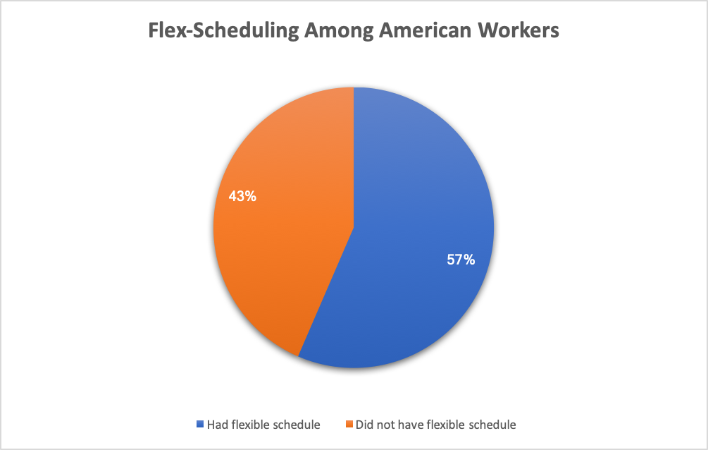
(U.S. Bureau of Labor Statistics, 2019)

References
Abadi, M. (2018, March 8). 11 American work habits other countries avoid at all costs. https://www.businessinsider.com/unhealthy-american-work-habits-2017-11
Amway. (2020, March 25). Battling burnout: How a work-life balance can help eliminate stress. https://www.forbes.com/sites/amway/2020/03/25/battling-burnout-how-a-work-life-balance-can-help-eliminate-stress/?sh=5ca480223f66
Centers for Disease Control and Prevention. (2015, December 4). Improve morale & organizational reputation. https://www.cdc.gov/workplacehealthpromotion/model/control-costs/benefits/morale.html
Dunning, M. (2014, January 5). Employee assistance programs underutilized by employees. https://www.businessinsurance.com/article/20140105/news03/301059979#
Energize employees by emphasizing wellness. (2018, May). Buildings, 112(5), 34-38. http://search.ebscohost.com.libraryproxy.walshcollege.edu/login.aspx?direct=true&db=bsh&AN=129424467&site=ehost-live
Gaskell, A. (2016, January 15). Why a flexible worker is a happy and productive worker. https://www.forbes.com/sites/adigaskell/2016/01/15/why-a-flexible-worker-is-a-happy-and-productive-worker/?sh=39a6735714c4
Goetzel, R., Roemer, E., Holingue, C., Fallin, D., McCleary, K., Eaton, W., . . . Mattingly, R. (2018). Mental health in the workplace. Journal of Occupational and Environmental Medicine, 60(4), 322-330. https://www.ncbi.nlm.nih.gov/pmc/articles/PMC5891372/
Howington, J. (2020, August 20). How flexible work benefits companies and employees. https://www.flexjobs.com/employer-blog/the-benefits-of-allowing-employees-a-flexible-schedule/
Isaac, F. (2010, August). A Legacy of Health and Wellness. Benefits & Compensation Digest, 47(8), 1-17. http://search.ebscohost.com.libraryproxy.walshcollege.edu/login.aspx?direct=true&db=bsh&AN=52418457&site=ehost-live
Kuretich, C. (2020, April 8). The growing cost of mental health in the workplace. https://www.tlnt.com/the-growing-cost-of-mental-health-in-the-workplace-and-what-an-employer-can-do/#:~:text=The%20National%20Alliance%20on%20Mental,weeks%20and%20months%20to%20come.
Meares, C. (2014, July 14). How to use flex time to reduce summer child care costs. http://web.b.ebscohost.com.libraryproxy.walshcollege.edu/ehost/detail/detail?vid=0&sid=e18f86ec-f6a4-4f76-97f6-61f8c9ecff1d%40pdc-v-sessmgr05&bdata=JnNpdGU9ZWhvc3QtbGl2ZQ%3d%3d#AN=99190015&db=bsh
Pillay, S. (2010, April). Boosting Morale. Leadership Excellence, 27(4), 8. http://search.ebscohost.com.libraryproxy.walshcollege.edu/login.aspx?direct=true&db=bsh&AN=49008498&site=ehost-live
Place, A. (2020, September). Mental health is reaching a breaking point during COVID. Employee Benefit News, 34(5), 10. http://search.ebscohost.com.libraryproxy.walshcollege.edu/login.aspx?direct=true&db=bsh&AN=145668158&site=ehost-live
Pope, D. (2019, February). Good health boosts fitness, morale & productivity. Industrial Safety & Hygiene News, 53(2), 12. http://search.ebscohost.com.libraryproxy.walshcollege.edu/login.aspx?direct=true&db=bsh&AN=134341026&site=ehost-live
Schaeffer, J. (2010). The root causes of low employee morale. Supervision, 71(4), 3-4. http://search.ebscohost.com.libraryproxy.walshcollege.edu/login.aspx?direct=true&db=bsh&AN=51861805&site=ehost-live
SHRM. (2018, October 24). General: What is an employee assistance program (EAP)? https://www.shrm.org/resourcesandtools/tools-and-samples/hr-qa/pages/whatisaneap.aspx
Strengel, G. (2015, October 3). How a flexible workplace saves money and lifts morale. https://www.forbes.com/sites/geristengel/2012/10/03/how-a-flexible-workplace-saves-money-and-lifts-morale/?sh=36f719c06a24
U.S. Bureau of Labor Statistics. (2020, June 25). American time use survey summary. https://www.bls.gov/news.release/atus.nr0.htm
U.S. Bureau of Labor Statistics. (2019, September 24). Workers who could work at home, did work at home, and were paid for work at home, by selected characteristics, averages for the period 2017-2018. https://www.bls.gov/news.release/flex2.t01.htm
Witters, D., & Agrawal, S. (2011, October). Unhealthy U.S. Workers' Absenteeism Costs $153 Billion. https://news.gallup.com/poll/150026/unhealthy-workers-absenteeism-costs-153-billion.aspx

